ACIAR Project Acquittals – Guidance for Commissioned Organisations
The ACIAR Standard Conditions define an Acquittal as “the provision of an accurate report on funded activities, providing a breakdown of what the funds have been spent on and assurance that they have been spent on the intended purpose and in accordance with the terms of the Project Agreement.”

Clause 5.10 outlines the requirement for Commissioned Organisations to provide ACIAR with a written acquittal for each payment period, no later than 30 days after the expiration of each Payment Period. “Payment Period” means the periods: 1 January to 30 June; or 1 July to 31 December. The Payment Period may be reduced in length if the start or end date of the Project Agreement falls within the period.

The following details must be included in an acquittal:

(a) the amount of funding that was unspent during the previous reporting period and thus carried forward (if any), the project payment received during the reporting period (if any) and the amount expended during the reporting period;

(b) an explanation detailing the reasons for any delay in spending funds;

(c) sign-off by the Project Leader; and

(d) certification by a separate officer duly authorised by the Commissioned Organisation that the amounts, reported under clause 5.10(a), are correct and accurately reflect expenditure which has been incurred against each item for the purposes of the Project.

ACIAR Project Acquittals should be prepared on a Cash Basis: Incoming amounts (Part A Available Funds) are recorded when the funds are received; Outgoing amounts (Part B Expenditure) are recorded when the payment is made.

The ACIAR Acquittal template must be used for acquitting funds to ACIAR. Please do not add your organisation’s branding or modify the formatting/layout in any way.

Acquittals must be approved by the relevant Research Program Manager before the next project payment can be made.

Final Acquittals
A final acquittal reports on the withholding payment, together with any unacquitted amount from the previous reporting period. If there are any funds unspent in the Final Acquittal, ACIAR will send an invoice to the Commissioned Organisation to repay these funds.

Completing the Project Acquittal
Complete all cells highlighted in orange, before converting the spreadsheet into a PDF file.
From the top of the acquittal page, complete the following fields:

Reporting period: | This is the date range of the reporting period.  These dates will usually be: 1 Jan 20XX to 30 June 20XX  or 1 July 20XX to 31 Dec 20XX.  If this is the first acquittal for the project, the start date of the reporting period will be the Project Start Date.
Commissioned Organisation: | The legal name of your organisation.
Project Number: | This is the ACIAR Project number, in the format XXXX/20XX/XXX. Eg. HORT/2019/123

PART A. Available Funds:
These are the funds available to the project during the reporting period, consisting of:
- the Carried Forward amount (the Part C Total from the previous period’s acquittal) and
- the Total Project Payment received from ACIAR for the reporting period
These amounts should be added to the acquittal, along with the Payment Number (see below):

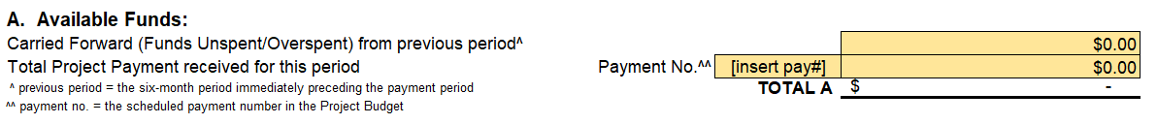

PART B. Expenditure:
Expenditure for the reporting period is broken down into:
- Commissioned Organisation Expenditure: This expenditure must be broken down into the listed cost categories: Personnel, Research Operating, Travel, Capital and Infrastructure. These categories are consistent with the project budget.
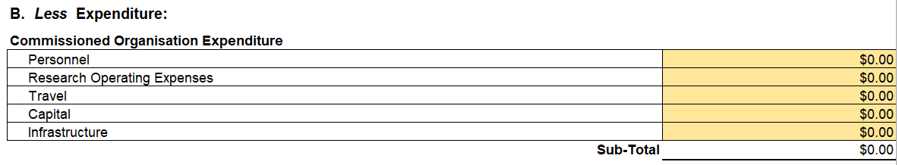
- Payments to Project Collaborators (optional for SRAs): All Project collaborators must be listed in this section, along with payment numbers and amounts paid to them during the reporting period. If no payment was made to a Project collaborator, they should still be listed but $0 should be entered.
In addition, the middle column (Y/N pull-down menu) must be completed to confirm that the Collaborators submitted a financial acquittal to the Commissioned Organisation for the previous reporting period. The purpose of this column is to confirm that Commissioned Organisations are making payments to project partners only after receiving an acquittal from them for the previous payment. Any NO responses should be explained in Part F, unless this is the first reporting period.
Collaborator acquittals should be retained by the Commissioned Organisation for record keeping purposes. ACIAR may request to see Collaborator acquittals at any time.
If Collaborator Payments were not the same as what was planned in the budget, please provide an explanation in the Other Comments box. For example, a payment was scheduled but was not made, an additional unscheduled payment was made, or dollar amounts were different to what was planned in the budget.
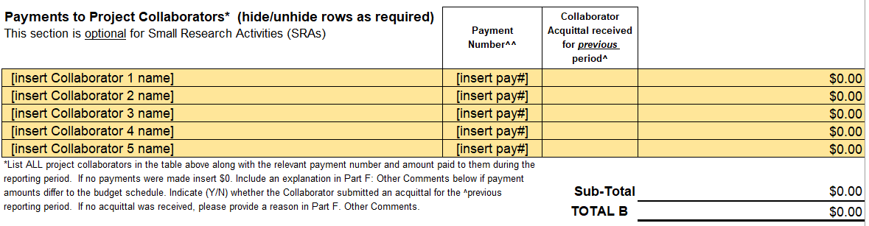
Please note: ACIAR staff will review the expenditure amounts and compare them to the project budget. If expenditure is significantly different to budgeted amounts, you will be asked to provide an explanation.

PART C. Funds Unspent/(Funds Overspent):
The Part C Funds Unspent/(Funds Overspent) amount is the difference between Available Funds (Part A) & Expenditure (Part B).

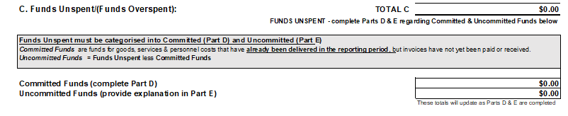

If the Part C total has funds overspent there is no requirement to complete Parts D & E. However, if the overspend (Total C) is greater than 20% of Available Funds (Total A), an explanation should be provided in Part F. Other Comments.

If the Part C total has funds unspent, these funds need to be categorised into Committed and Uncommitted amounts in Parts D and E below.

Part D: Committed funds
Committed Funds are funds for goods, services and personnel costs that have already been delivered in the reporting period, but invoices have not yet been paid or received. Committed Funds need to be detailed in Part D. These amounts should be broken down into cost categories for the Commissioned Organisation and project payments to the Collaborators. This section should not include funds for activities budgeted for in the next period.
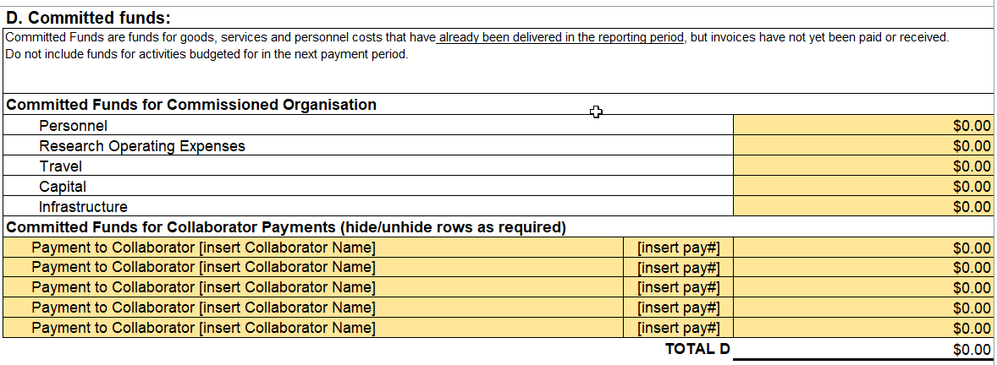

Part E: Uncommitted funds
After deducting Committed funds from Funds Unspent, the remaining amount is considered to be Uncommitted. Please provide an explanation for these uncommitted funds in Part E. This explanation can be given as written comments, with the option to provide an itemised breakdown. Note: Any plans to reallocate funds should not be included in the acquittal, as these matters should be discussed with the relevant Research Program Manager.
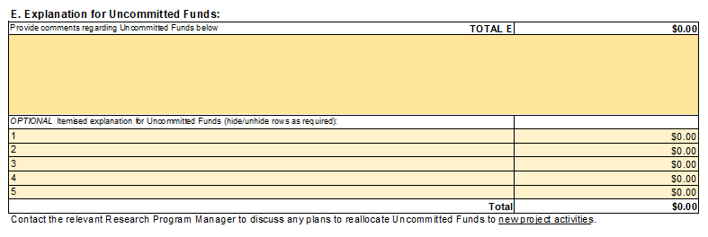

Part F - Other Comments
The Other Comments box should be used to provide additional details about collaborator payments, collaborator acquittals, overspends and any other relevant information.
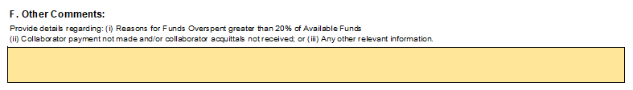

Part G - Certification from the Commissioned Organisation
Completed ACIAR acquittals should be converted to a PDF file – ensuring that text boxes are expanded so that all comments are visible. Acquittals must be signed by the Project Leader and the Authorised Officer from the Commissioned Organisation. Date-stamped digital signatures are acceptable.

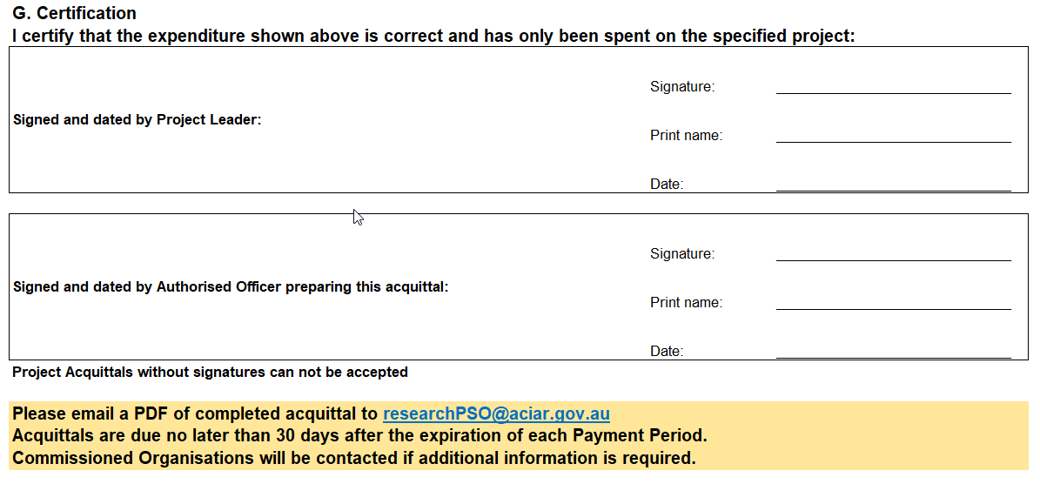

Once complete, acquittals should be sent via email to researchPSO@aciar.gov.au

A print friendly version of these instructions can be found on the ACIAR website: https://aciar.gov.au/project-tools/project-acquittals

ACIAR Standard Conditions: https://www.aciar.gov.au/Standard-Contract-Conditions-and-Intellectual-Property-Policy
Clause 5.7 for Small Research Activities (SRAs)
Acquittals must be submitted for each reporting period, regardless of whether a payment has been received.
A portion of the final project payment withheld until ACIAR acceptance of the Final Report.
If the acquittal is for the first project payment this amount will be zero.
Scheduled payment number in the Project Budget
ACIAR Project Agreements specify the requirement for six-monthly financial acquittals to be submitted to Commissioned Organisations by Collaborating Institutions.

