Project annual report

Instructions for preparing an annual report

The purpose of the Project Annual Report is to highlight research outcomes and progress, and to identify issues such as impending problems and potential opportunities. The Annual Report creates the opportunity for a discussion on major progress, issues and opportunities between the project team and ACIAR, enabling adaptive management.

Annual reports are required for project monitoring by ACIAR and for feedback to project collaborators. Annual reports are also used by ACIAR to capture information for whole of government reporting on Australia’s aid program. Reports should focus on progress against the agreed project objectives, outputs and milestones as per the project document approved by ACIAR and how this relates to ACIAR’s objectives as outlined in the Ten Year Strategy 2018-2027. The report should also highlight any significant new activities that were not in the design and unexpected impacts. Annual reports should not repeat information from earlier annual reports.

Project Annual Reports are due 14 July each year for all projects that were active before 1 January of that year, until the final year of the project when a Final Report is required. An electronic copy should be submitted to the relevant ACIAR Research Program Manager by the commissioned organisation / International Agricultural Research Centre (IARC). It is expected that the report is produced through active engagement of all partners.

The annual report template is a blank Word file that contains the basic headings and formatting styles for preparing the annual report for an ACIAR project.

These instructions describe what to consider in developing the content and how to use the template formatting. All headings in the template must be addressed. You may add headings at level 2-4 as required.

The template for completing the Annual Report may be found on the ACIAR website: https://www.aciar.gov.au/Annual-and-Final-Reports
File naming guidelines:

The Annual Report should be named XXX-20XX-XXX Annual Report 19-20
(eg FST-2017-014 Annual Report 19-20).

The Excel project Publication list should be named XXX-20XX-XXX Publications List 19-20 (eg. FST-2017-014 Publications List 19-20).

Summary of contents and number of pages in the annual report
Section | Heading | Number of pages
1 | Progress summary | max 750 words
2 | Achievement against activities and outputs/milestones | max 3 pages
3 | Impacts | max 3 pages
4 | Training activities | max 1 page
5 | Intellectual property | max ½ page
6 | Variations to future activities | max ½ page
7 | Variations to personnel | max ½ page
8 | Problems and opportunities | max 1 page
9 | Budget | max ½ page

Progress summary
The Progress summary should be no more than 750 words.

The summary should focus on the objectives, activities, outputs and milestones for the reporting period as per the project document or subsequent variation approved by the ACIAR Research Program Manager.

Append copies of published papers or any detailed reports on project activities prepared for other purposes. These will not be released.

Achievements against project activities and outputs/milestones
This section requires reporting on achievements against project activities and outputs/milestones. There are two sections: 2.1 will be reported for each objective in table form and 2.2 will be a summary of achievements, for publication on the ACIAR website.

Achievements to date
In this section (maximum 3 pages), provide a systematic account of how the project is progressing towards achieving its objectives. The report needs to be clear and specific about what has and has not been achieved.

State how the project has met milestones (time-bound outputs) that are due as listed in the Project proposal and progress that is being made towards milestones that are not yet due.

Summary of achievements to date (for ACIAR website)
This Summary will be published on the ACIAR website and should be written in dot- point format, minimising the use of scientific jargon and acronyms (no more than 250 words).
Please note that this summary will be made publicly available on ACIAR's website and in other communication materials. Do not include any commercially or institutionally-sensitive material in this summary (this information should be included in section 8).

Project Stories
If your project has a significant impact story or standout achievement that could potentially be shared by the ACIAR Outreach Team, please provide further information via question prompts at the link. Project Stories.

Impacts
This is a key section for ACIAR (maximum 3 pages).

While acknowledging that the project is still in progress, identify any impacts that have or will soon occur, both planned and unexpected.

In describing impacts achieved during the life of the project, provide evidence for the impacts, if possible in quantitative terms. Impacts may be positive or negative and either anticipated or unanticipated.

Do not confuse outputs (something the project makes), with impacts (something the project makes happen). A journal publication is an output; application by other scientists of a novel methodology described in a journal paper is a scientific impact.

Scientific impacts
A scientific impact is the change in scientific practices that have occurred outside the project because of the findings of the project.

Capacity impacts
A capacity-building impact is a change in the knowledge and skills of individuals (particularly those in the partner country) that has occurred through their participation in the project and its training elements. For the impact to be fully realised, the participants would use the new knowledge and skills in areas outside the scope of the project.

Capacity building also refers to equipment (hardware and software), buildings and infrastructure provided through the project that enable participants to continue R&D outside the scope of the project.

Community impacts
A community impact should be interpreted as an impact beyond the scientific sphere. It refers to any change in social, economic, or environmental conditions due to the uptake of information or technology by individuals or groups not directly involved or collaborating on the project (including government agencies and NGOs) as a result of the project.

Economic impacts
Economic impacts refer to changes in an individual’s, a community’s or a country’s monetary wellbeing while environmental impacts refer to changes in natural resources. Examples of economic impact would be farmer families having a higher disposable income as a consequence of:
- adopting a new crop variety
- policy changes that opened up new markets
- higher prices for market-oriented products
- more efficient use of resources.

These changes may be positive or negative and could either be anticipated or unanticipated.

Social impacts
Social impacts refer to changes in equity, culture, health, gender roles, and the religious, political, ethnic or demographic status of an individual or community.

Environmental impacts
Environmental impacts refer to changes in how natural resources are managed and how the changed management affects the state of the natural resource (soil, water, air, biodiversity).

Communication and dissemination activities
Provide information on communication and dissemination activities, e.g. coordination meetings, conference papers, demonstration sites, field days, workshops, including those not directly related to the project.

List in Appendix 1 any project related publications that have been produced during the reporting period.

Training activities
Describe significant training activities during the reporting period. List names, institutions, degree, dates, topic, and sources of funding (maximum 1 page).

Intellectual property
Note any significant IP issues that may have arisen in the reporting period (maximum ½ page).

Variations to future activities
Indicate variations that are suggested for the remainder of the project. Clearly state what action, if any, is required (maximum ½ page).

Variations to personnel
Provide details of any significant project personnel changes during the reporting period (maximum ½ page).

Problems and opportunities
Discuss any research or logistical problems encountered during the reporting period, and their importance and implications for future research/extension. What approaches is the team using to attempt to overcome these problems (maximum 1 page)?

Budget
Provide a summary of expenditure and discuss any significant variations from approved budget during the reporting period (maximum ½ page).

Appendices
Appendices offer an opportunity to provide additional information that otherwise might not be reported elsewhere. A good example is tabulating unpublished data in a way that others can use it in the future, or providing more detailed descriptions of methodologies (e.g. a survey form).

The only mandatory appendix is the Microsoft Excel Annual Report Appendix One publications list 2019-20, which needs all publication types to be listed. https://www.aciar.gov.au/Annual-and-Final-Reports

Formatting styles

Formatting styles can be accessed from:
- the Formatting toolbar;
- the task pane at the right of the screen; or
- the specially created ACIAR styles toolbar. If you do not see the toolbar, from the Tools menu select Customise, click on the toolbar tab and check the ACIAR styles toolbar.

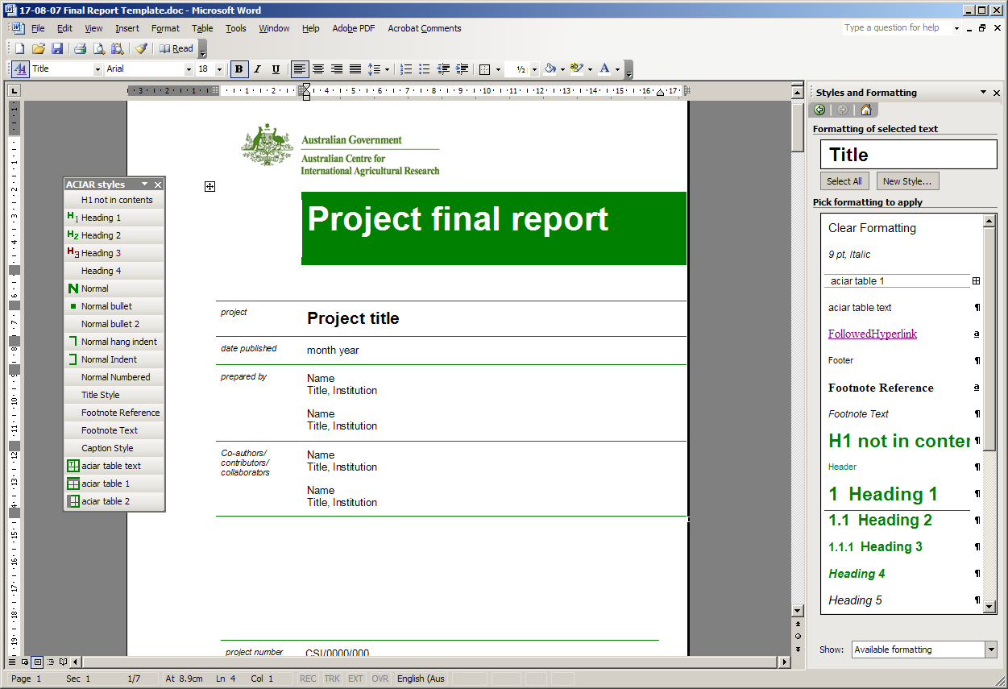
3
2
1

Heading 1 | Heading 1 is an auto-numbered heading
Heading 2 | Heading 2 is an auto-numbered heading
Heading 3 | Heading 3 is an auto-numbered heading
Heading 4 | Heading 4
Normal text | text text text text text text text text text text text text text text text text text text text text text text text text text text text text text
Normal bullet | - text text text text text text text text text text text text
Normal bullet 2 | - text text text text text text text text text text text text
Normal indent | text text text text text text text text text text text text text text text text
Normal Numbered | - an auto-numbering style for text  - text text text text text text text text text  - text text text text text text text
Normal hang indent | This style can be used if you want to manually number some points e.g. a,b,c or I, ii, iii. You need to add a number and tab to align the text.  a. Normal hang indent can be used to manually number some points.  b. Normal hang indent can be used to manually number some points.
Caption style | text text text text text text text text text text text text text text text text
Footnote reference and text | 1 Footnote reference  Footnote text

There are two defined table styles you can use if appropriate to the type of information.
To apply formatting, select the table and apply the table text style and then apply one of the table styles shown below.

aciar table 1 style
Table 1 | Column | Column | Column
Row
Row
Row

aciar table 2 style
Table 1 | Column | Column | Column
Row
Row
Row

